|  |  |  |
| --- | --- | --- |
| Exercise 3 – Forward! | Group Number |  |

**Move Tank Documentation**

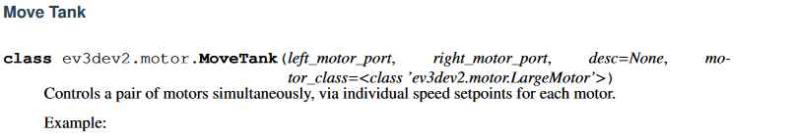

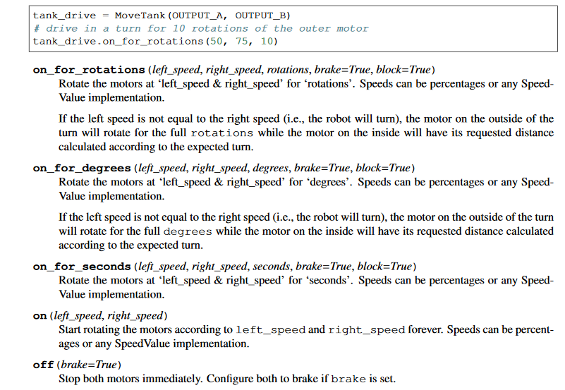

**Exercises**

|  |  |
| --- | --- |
| 1. How far does the robot travel in one wheel revolution? | cm |
| 1. How wide is a wheel? | cm |
| 1. How far apart are the wheels? | cm |

Write down the parameters you used when calling the “on_for_rotations” method:

|  |  |  |  |
| --- | --- | --- | --- |
|  | left_speed | right_speed | rotations |
| 1. Go Faster |  |  |  |
| 1. Go backwards |  |  |  |
| 1. Turn left 90 degrees |  |  |  |
| 1. Turn right 90 degrees |  |  |  |